|  |
| --- |
| **National University of Computer and Emerging Sciences** |
| Lab Manual  “ASP.NET Database Connectivity and Data Population” |

|  |
| --- |
| **Database Systems Lab** |
| **Spring 2024** |

Department of Computer Science

FAST-NU, Lahore, Pakistan

**Table of Contents**

Objectives 2

Task Distribution 2

Master Pages 3

Database Connectivity 11

**Table of Figures**

Figure 1: Create a new web application 3

Figure 2: Add new item from solution explorer 4

Figure 3: Add a new master page named MyMaster.Master 4

Figure 4: Add an existing item called MyCssFile.Css 5

Figure 5: Add new folder named Images 6

Figure 6: Add existing items to a folder 6

Figure 7: Add images from Resources/images folder to Images folder of web application 7

Figure 8: Add CSS file MyCssFile.css in MyMasterPage.Master 7

Figure 9: Modify MyMasterPage.Master 8

Figure 10: Add a new Home.aspx page 9

Figure 11: Add MyMasterPage.Master to Home.aspx 9

Figure 12: Verify Home.aspx and Search.aspx in solution explorer 10

Figure 13: Execute project to check home page and search page 10

Figure 14: Connection string values 12

Figure 15: Add connection string to Web.config file 12

Figure 16: Add a new myDAL.cs class in a newly created DAL folder 13

Figure 17: Add namespaces and reference to connection string in myDAL.cs file 14

Figure 18: Modify myDAL.cs file with SelectItem() function to get all items 15

Figure 19: Modify Home.aspx page and add a GridView 16

Figure 20: Modify Home.aspx.cs file to load data in GridView 17

Figure 21: Execute project to view the loaded GridView 18

Figure 22: Modify Search.aspx page to add search button and GridView 19

Figure 23: Add SearchItem() in myDAL.cs file to search single item 20

Figure 24: Modify Search.aspx.cs file to apply server side logic 21

Figure 25: Search item Soap in the database 22

Figure 26: Search for an item not present in the database 22

# Objectives

* Understanding ASP.NET Master Pages
* Database connectivity with ASP.Net web forms application
* Populating data in GridView using SQL query and stored procedures

# Task Distribution

|  |  |
| --- | --- |
| Total Time | 60 Minutes |
| Introduction | 10 Minutes |
| Demo + Practice | 50 Minutes |

# Master Pages

* Master pages allow you to create a consistent look and behavior for all the pages (or group of pages) in your web application.
* A master page provides a template for other pages, with shared layout and functionality.
* They allow you to centralize the common functionality of your pages so that you can make updates in just one place.
* The master page defines placeholders for the content, which can be overridden by content pages.
* The output result is a combination of the master page and the content page.
* The content pages contain the content you want to display.
* When users request the content page, ASP.NET merges the pages to produce output that combines the layout of the master page with the content of the content page.
* File name extension **.master**

For more info visit:

<https://docs.microsoft.com/en-us/previous-versions/aspnet/wtxbf3hh(v=vs.100)>

**The following exercise will demonstrated how to create and use Master Pages**

1. Create a New Project in Visual Studio, selecting ASP.Net Web Application and .Net Framework 4 (your latest version) in middle pane and Visual C# Web in left pane. Name your project **MyWebSite** (follow figure 1)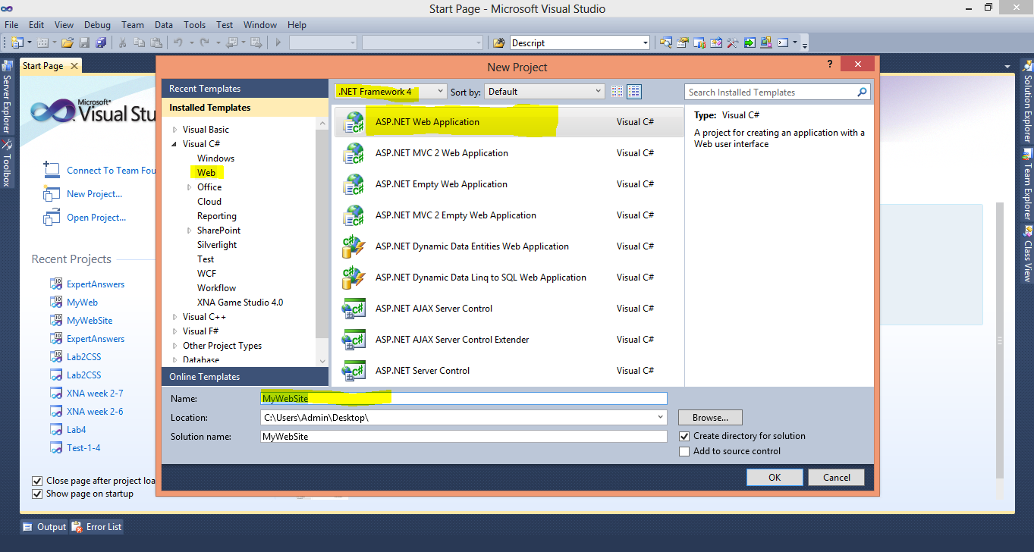

*Figure 1: Create a new web application*

1. Add Master Page in your Project, using Add New Item option from Solution Explorer (follow figure 2 and 3). Name this Master Page as **MyMasterPage.Master.**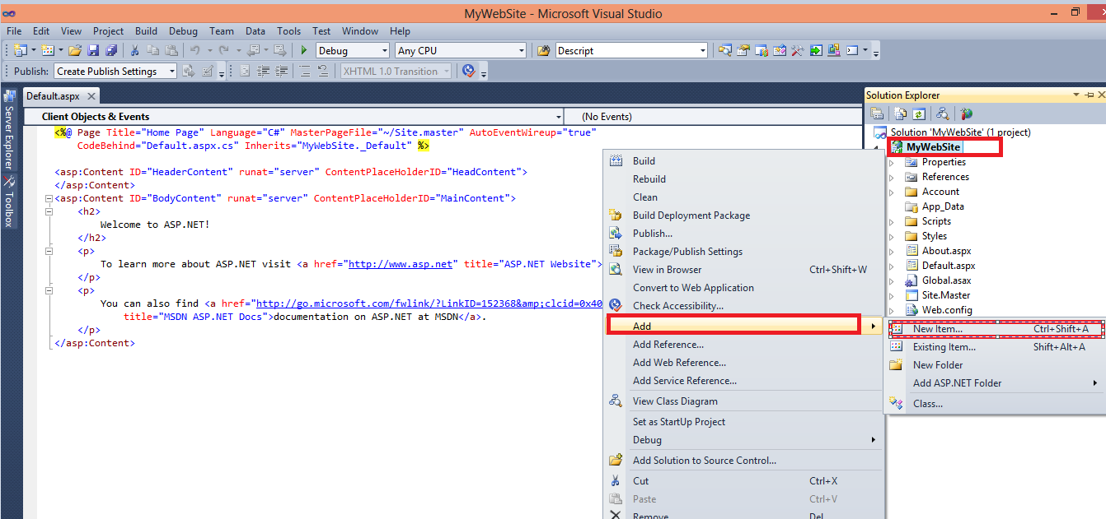

*Figure 2: Add new item from solution explorer*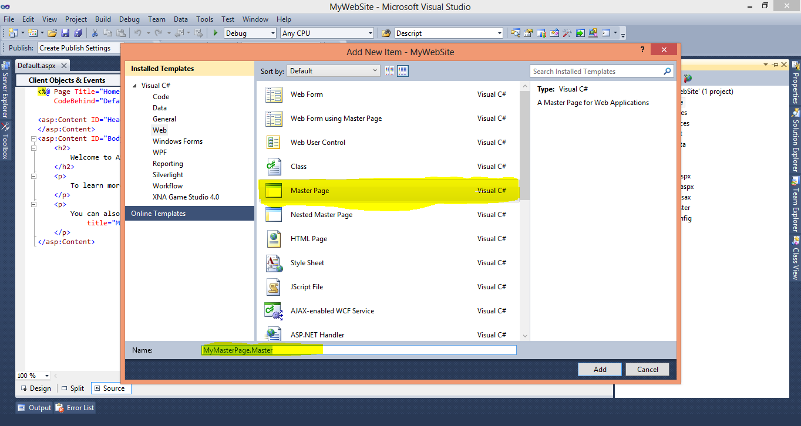

*Figure 3: Add a new master page named MyMaster.Master*

1. Now, we will add CSS file and images in our project that will be used in styling the Master Page. We have used the snow_glass_215 template given in the link below.

***The web template is downloaded from***

*http://all-free-download.com/free-website-templates/*

***You can also download template from this website for your projects***

***The template used for this Lab Exercise is***

*http://all-free-download.com/free-website-templates/snow_glass_215.html*

1. Add the CSS file (**MyCssFile.CSS** given in Resource folder along with manual) in your project using Add Existing Item (follow figure 4)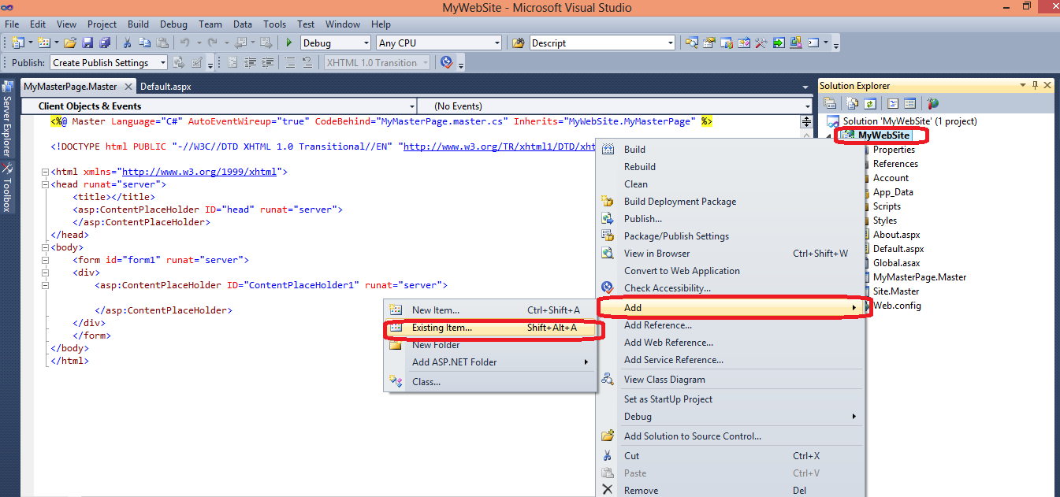

*Figure 4: Add an existing item called MyCssFile.Css*

1. After adding CSS file create new folder in your project named Images using New Folder option (follow figure 5)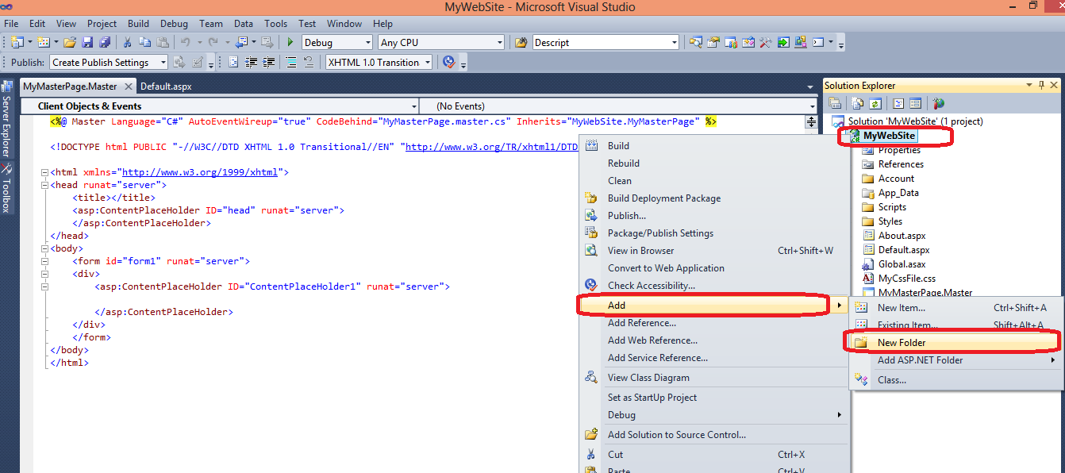

*Figure 5: Add new folder named Images*

1. Now, add all the images given in Resources\images folder in this Images folder (follow figure 6 and 7)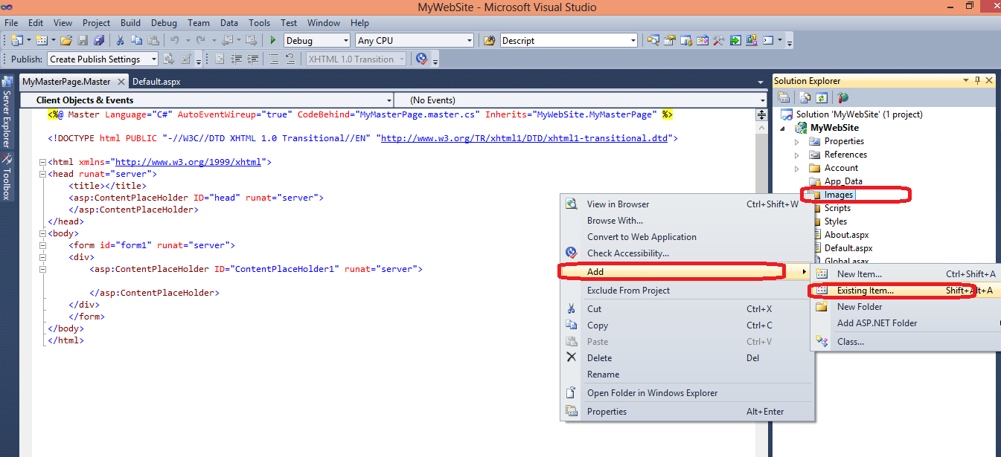

*Figure 6: Add existing items to a folder*

*Figure 7: Add images from Resources/images folder to Images folder of web application*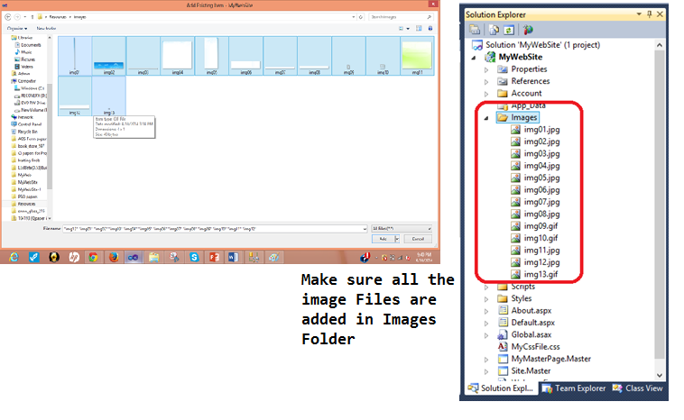

1. Now, open **MyMasterPage.Master** and drag drop **MyCssFile.css** file in <head> tag (follow figure 8)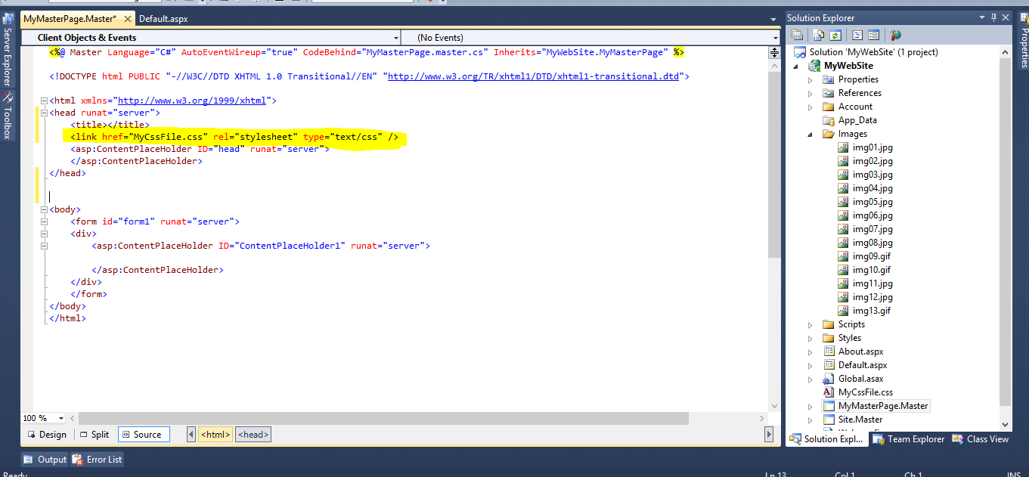

*Figure 8: Add CSS file MyCssFile.css in MyMasterPage.Master*

1. Open the **MasterPage_Body.txt** file given in Resources folder and copy all the contents, replace everything inside the <body> tag of **MyMasterPage.Master** with copied content (follow figure 9)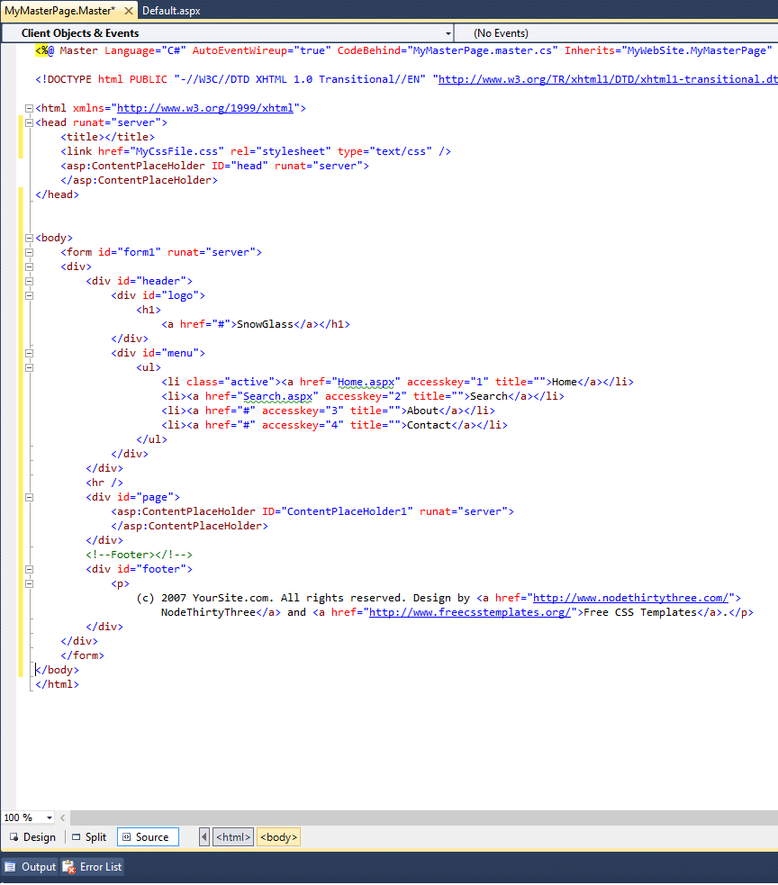

*Figure 9: Modify MyMasterPage.Master*

1. Now, create two web forms name **Home.aspx** and **Search.aspx** using Add New Item, which will use our Master Page **MyMasterPage.Master**.Add the new web forms using **MyMasterPage.Master** (follow figure 10 and 11)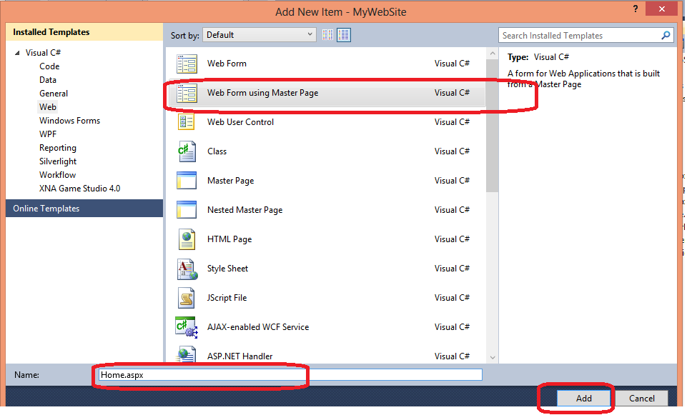

*Figure 10: Add a new Home.aspx page*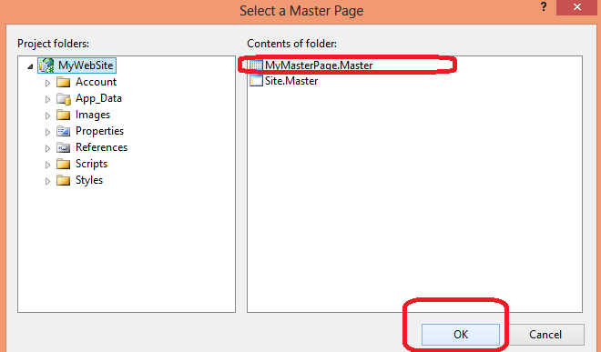

*Figure 11: Add MyMasterPage.Master to Home.aspx*

1. Confirm that the two web forms are added form **Solution Explorer** (follow figure 12)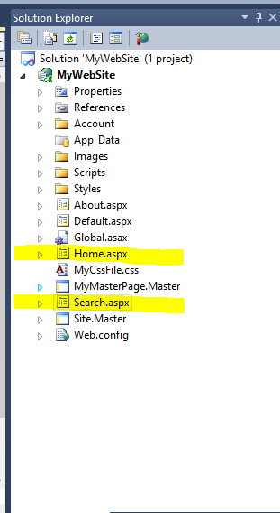

*Figure 12: Verify Home.aspx and Search.aspx in solution explorer*

1. Execute your project and see the result in browser. Click on home and search and see the change in address bar (follow figure 13)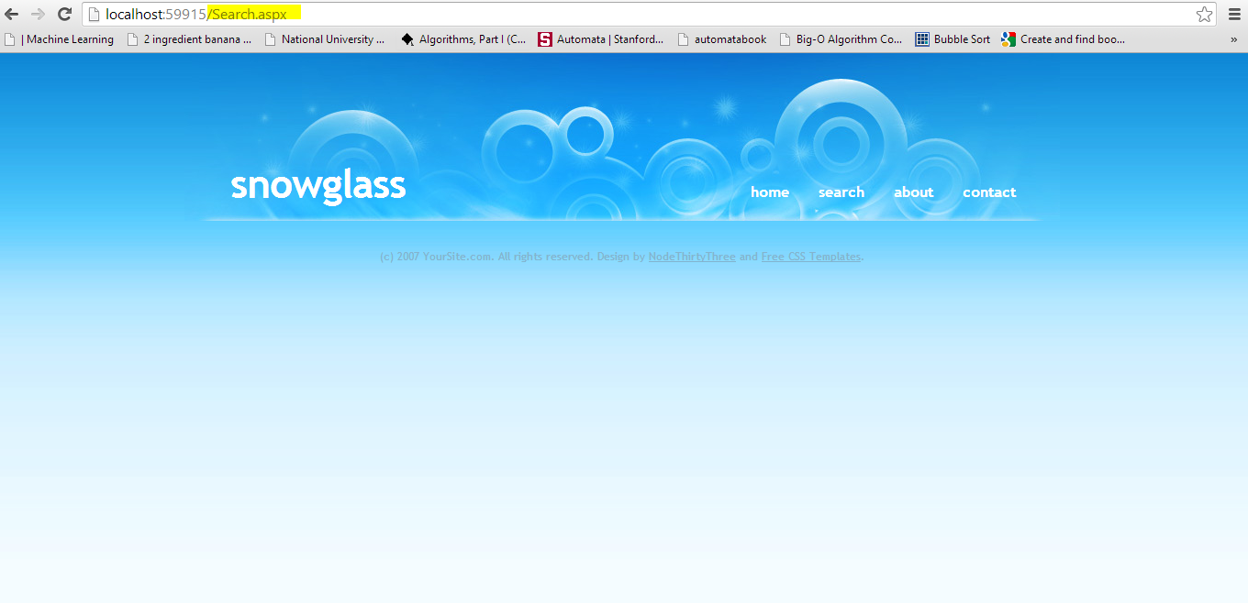

*Figure 13: Execute project to check home page and search page*

1. **Achievement Unlocked!** You have successfully created an **ASP.NET** Master Page name **MyMasterPage.Master** and used it in **Home.aspx** and **Search.aspx**. Save your work for the next exercise.

# Database Connectivity

This exercise will show how to connect the web site with the MSSQL database and how to access the data present in the database.

1. Open the **DataBaseQueries.sql** file in **Resources** folder, and execute it in MSSQL Server.
2. This will create a new database with name **DBConnectDemo,** an **items** table, and **SearchItem** stored procedure**.** We will use the data from this table and result from this procedure in our web site.
3. Use the same web project in previous exercise. Create a database connection string in **Web.config** file

**Format of Connection String**

*<connectionStrings>*

*<add*

*name="SQLDbConnection"*

*connectionString="Data Source=SQlServerName; Initial Catalog=YouDatabaseName; User Id=userid; Password= password"*

*providerName="System.Data.SqlClient" />*

*</connectionStrings>*

**More info about connection string**<http://msdn.microsoft.com/en-us/library/jj653752%28v=vs.110%29.aspx>

* **Data Source**: server name i.e. **cactus** or **local**
* **Initial Catalog**: database name which has your table, stored procedure and views i.e. **DBConnectDemo**
* **User Id**: login name for database
* **Password**: password for database

An easy way to get these values are from MSSQL Server Connect to Server window (follow figure 14)

**Our Sample Connection Strings**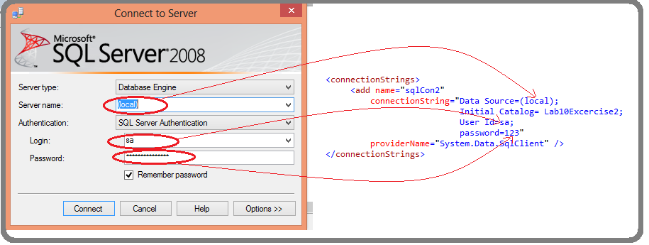

*Figure SEQ Figure \* ARABIC 14: Connection string values*

* Connection string with window authentication for local host

*<connectionStrings>*

*<add*

*name="**sqlCon1**"*

*connectionString="Data Source=(local); Initial Catalog=Lab10Excercise2; Integrated Security=True"*

*providerName="System.Data.SqlClient" />*

*</connectionStrings>*

* Connection string with SQL server authentication for server name MYSQLSERVER

*<connectionStrings>*

*<add*

*name="sqlCon1"*

*connectionString="Data Source=(local); Initial Catalog=Lab10Exercise2; User ID=sa; password=123"*

*providerName="System.Data.SqlClient" />*

*</connectionStrings>*

1. Add your connection string in **Web.config** file (follow figure 15)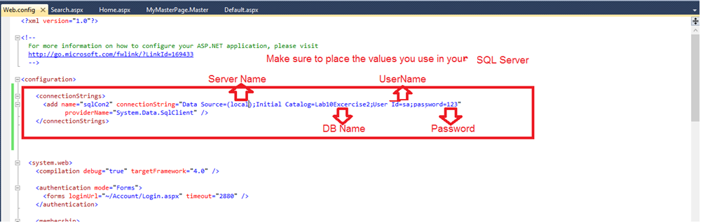

*Figure 15: Add connection string to Web.config file*

1. Creating DAL (Data Access Layer), to get data from MSSQL. Create new folder in your project named DAL, in this folder Add New Item of type Class and name it **myDAL.cs** (follow figure 16)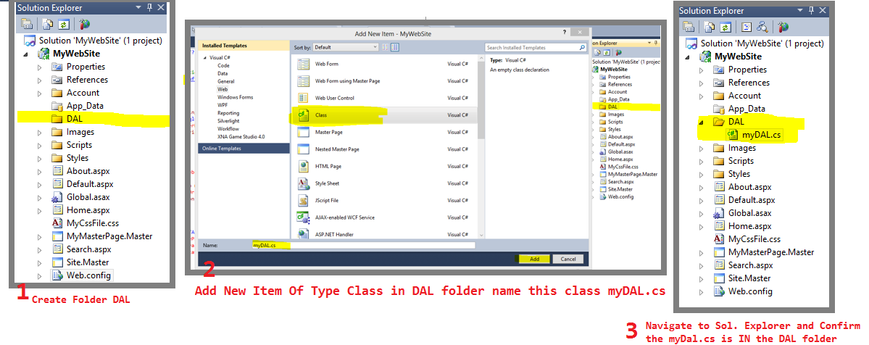

*Figure 16: Add a new myDAL.cs class in a newly created DAL folder*

1. Open **myDal.cs** file and add the reference to database connection string, namespaces for SQL and Datasets (follow figure 17)

**Reference to Connection String**

*private static readonly string connString =*

*System.Configuration.ConfigurationManager.ConnectionStrings["sqlCon1"].ConnectionString;*

**Namespaces for SQL and Datsets**

*using System.Data;*

*using System.Data.SqlClient;*

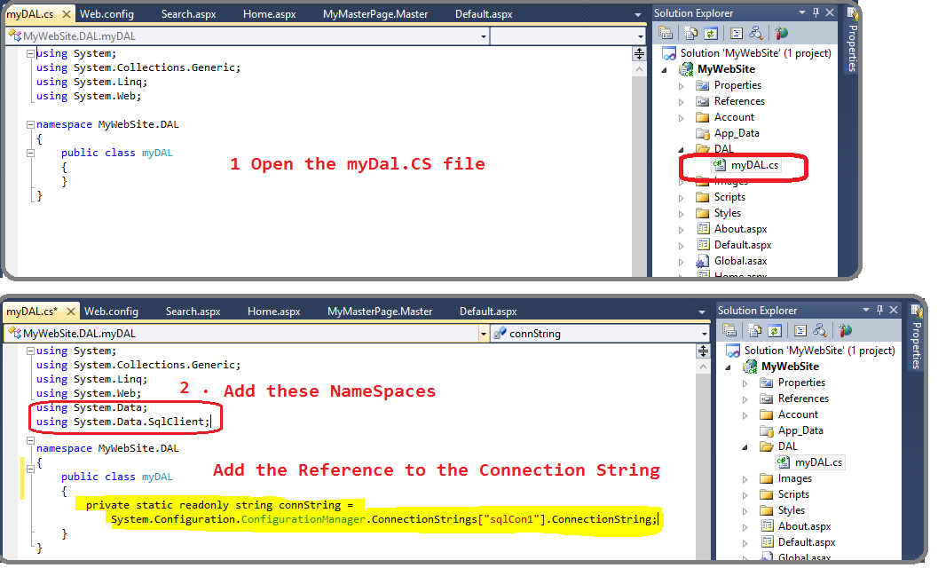

*Figure 17: Add namespaces and reference to connection string in myDAL.cs file*

1. Create a function in **myDal.cs** class that will perform a simple ***select * from Item***query on Database and get the result set. Copy and paste the function ***SelectItem()*** from **Function_SelectItem.txt** file (follow figure 18)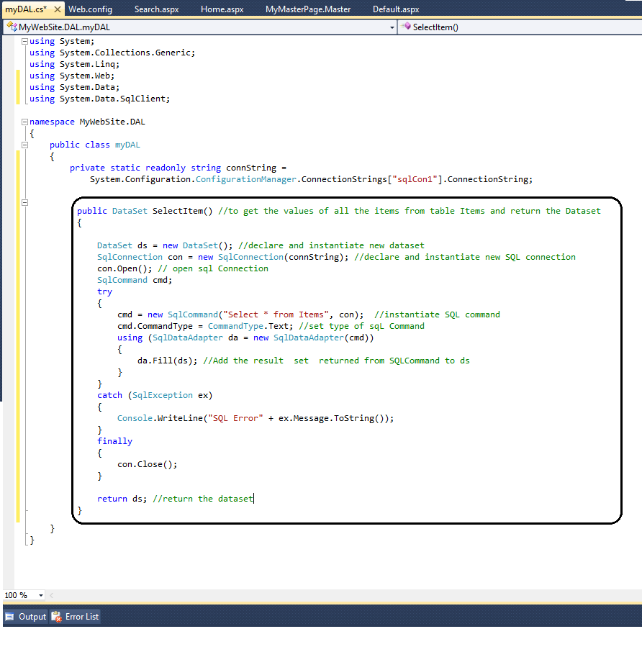

*Figure 18: Modify myDAL.cs file with SelectItem() function to get all items*

1. Use this **SelectItem()** function for displaying the result on home page **Home.aspx** by adding a **GridView** with **ID=“ItemGrid”**. You can see that the grid already looks like a table, all you need to do is fill the values in it from your query. The contents of grid are changed or updated from server side which is the **aspx.cs** file. Open your **Home.aspx.cs** file and modify it using the changes given in **Home_aspx_CS.txt** file (follow figure 19 and 20)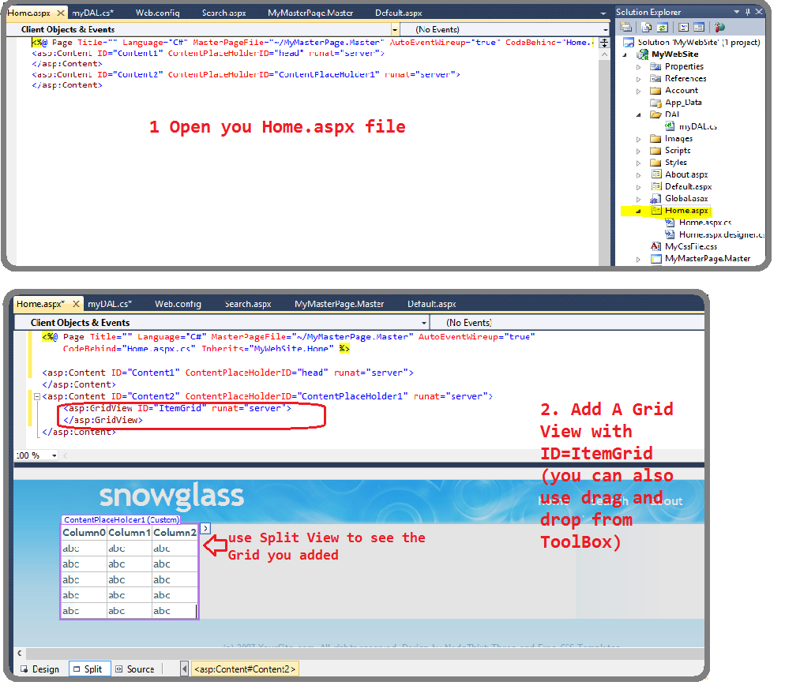

*Figure 19: Modify Home.aspx page and add a GridView*

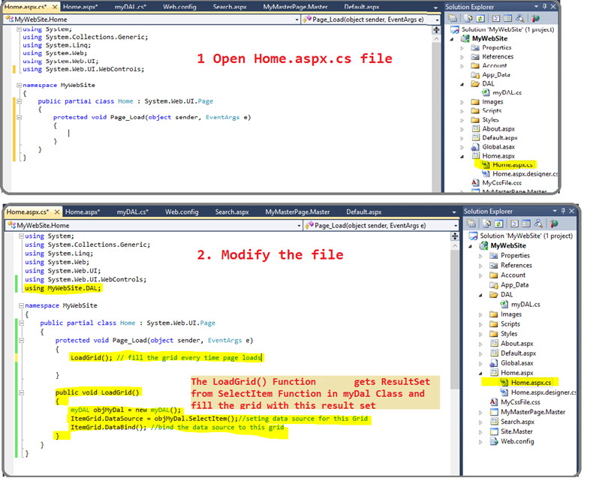

*Figure 20: Modify Home.aspx.cs file to load data in GridView*

1. Execute your project, if everything goes right, the home page should look like the page given below. You have successfully used the result of a simple query on your website. **Achievement Unlocked!** (follow figure 21)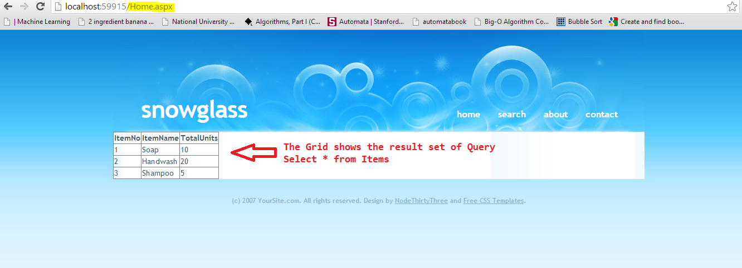

*Figure SEQ Figure \* ARABIC 21: Execute project to view the loaded GridView*

1. Now, we will call MSSQL stored procedure from ASP.NET. We will learn how to pass input parameters, how to get output parameters and result sets from stored procedures. We have already created a web form **Search.aspx** in our web application and **SearchItem** stored procedure in our **DBConnectDemo** database. Now, we will add the search functionality on our page, by getting the **ItemName** from user and querying the database for that item using **SearchItem** MSSQL stored procedure. The procedure will return the dataset and output found=1, if any item with that name exists, and found=0 if no item is found.
   1. Open **Search.aspx** page and modify the code, adding **TextBox** and **Button** and a **GridView** to show the result of search. Code is given in file **Search_Aspx.txt**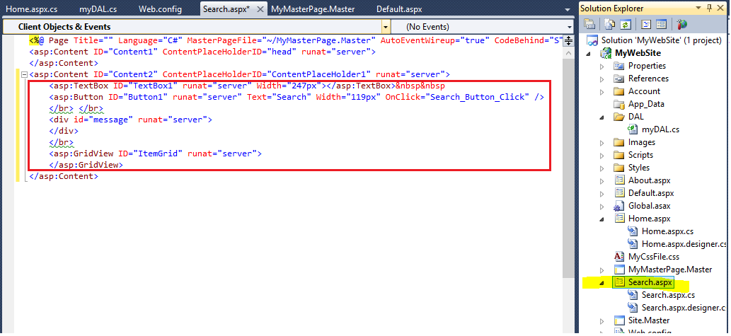

*Figure SEQ Figure \* ARABIC 22: Modify Search.aspx page to add search button and GridView*

* 1. Open **myDal.cs** file and add **SearchItem()** function in it from the **Function_Searchitems.txt** file (follow figure 23)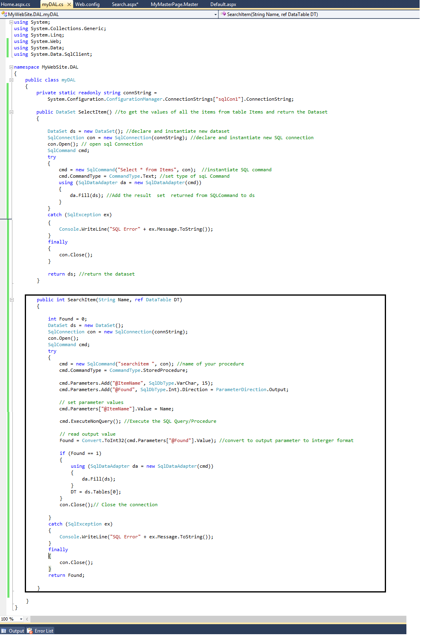

*Figure SEQ Figure \* ARABIC 23: Add SearchItem() in myDAL.cs file to search single item*

* 1. Use this new function **SearchItem()** in server side **Search.aspx.cs**. Open **Search.aspx.cs** file and modify with code given in **Search_Aspx_CS.txt** file (follow figure 24)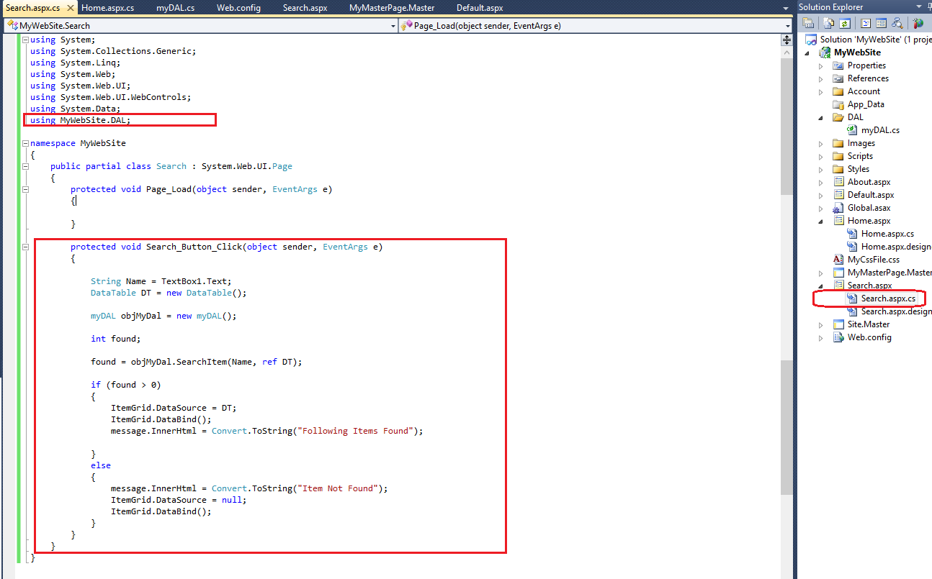

*Figure SEQ Figure \* ARABIC 24: Modify Search.aspx.cs file to apply server side logic*

* 1. Execute your project. Type “Soap” in TextBox and click Search. The following results should appear. **Achievement Unlocked!** (follow figure 25)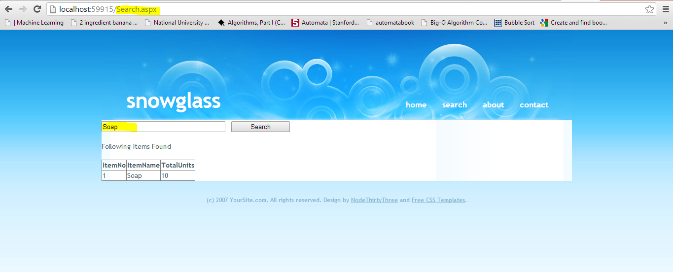

*Figure SEQ Figure \* ARABIC 25: Search item Soap in the database*

* 1. Now, type some random string in TextBox and click Search. The following results should appear (follow figure 26)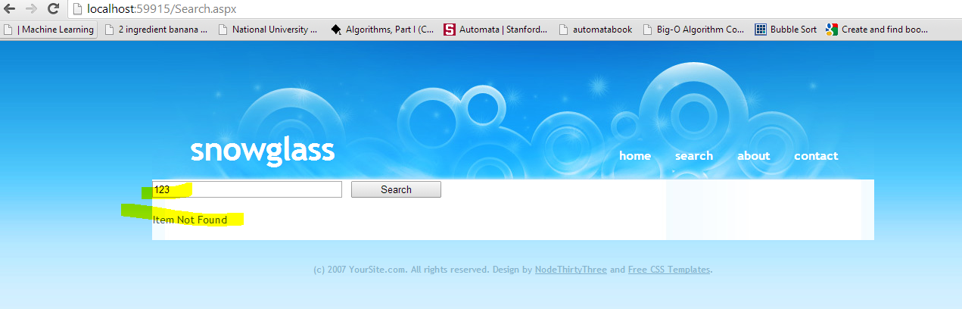

*Figure SEQ Figure \* ARABIC 26: Search for an item not present in the database*

**Post lab**

Make another webpage with search bar in it. It displays only the item with quantity  greater than 5 otherwise it should display ‘Out of stock’.

**Post lab**

Make another webpage with search bar in it. It displays only the item with quantity greater than 5 otherwise it should display ‘Out of stock’.